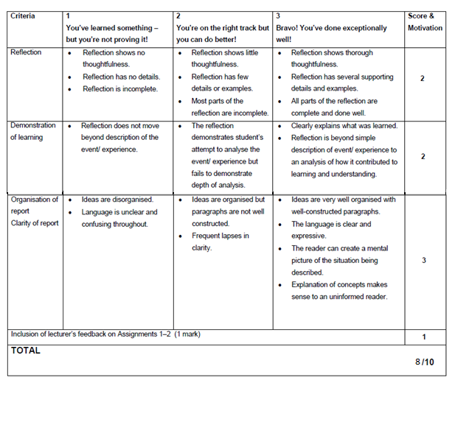

Reflection :

At the start of my 3rd year, I was nervious and still a bit uncertain of where my future might go, or what might be the right path for me to take.

During the last few weeks as we went deeper with php I realised how endless possibilities might be.From the start of the first Hello World to where I’ve gotten now. Realizing that almost anything can be created when you place your mind to it, and a bit of creativity.

Php has taught me many things, and one of them are for certain, that my future as a developer is a endless road, there will always be more to learn, and alwyays be more to develop, but I welcome this journey and know it’s not a job, but a passion.

Demostration of Learning:

I clearly show what I have learned in the last couple of months, and integrate it in my assignments.

I try to find ways of further improving on what I have been taught or find easier/shorter ways of completing the task with same or alternative outputs.

My demostraition is merely a small development as to how far I have come, and how much there still is that can be done.

Clarity of Report:

My report has been completed as a guide that is easy to understand by all.

The words used in the guide can be understood by all, and all information is easy to understand and follow.

I used flowcharts and diagrams to further present What is happening within my assignments and how everything links up.

In my guide I describe a very easy picture to follow and imagine, even when you have not yet seen the application, you can still follow and will know what is happening at each step.

The applications as a whole is easy to understand by anyone and first time users can easily get comfortable with the program and learn their way around it without much or any help at all.

Inclusion:

Php programming has open many doors to me, and showed me that work can also be passion, it doesn’t always have to be difficult or not enjoyable, with development, that is all you will ever find.